From: <https://open.substack.com/pub/rwmalonemd/p/the-first-mandatory-vaccination-campaign?r=doii8&utm_campaign=post&utm_medium=web>

The First Mandatory Vaccination Campaign That Crippled America’s Pilots

The forgotten history of the military's disastrous anthrax vaccination campaign.

Author: Robert W Malone MD, MS

Date: 4 hr ago 20230216

Likes: 307 Comments: 69

**The First Mandatory Vaccination Campaign That Crippled America’s Pilots**

The forgotten history of the military's disastrous anthrax vaccination campaign.

[](https://substack.com/profile/49176289-robert-w-malone-md-ms?utm_source=author-byline-face)

[**Robert W Malone MD, MS**](https://substack.com/profile/49176289-robert-w-malone-md-ms)

4 hr ago

307

[69](https://rwmalonemd.substack.com/p/the-first-mandatory-vaccination-campaign/comments)

[[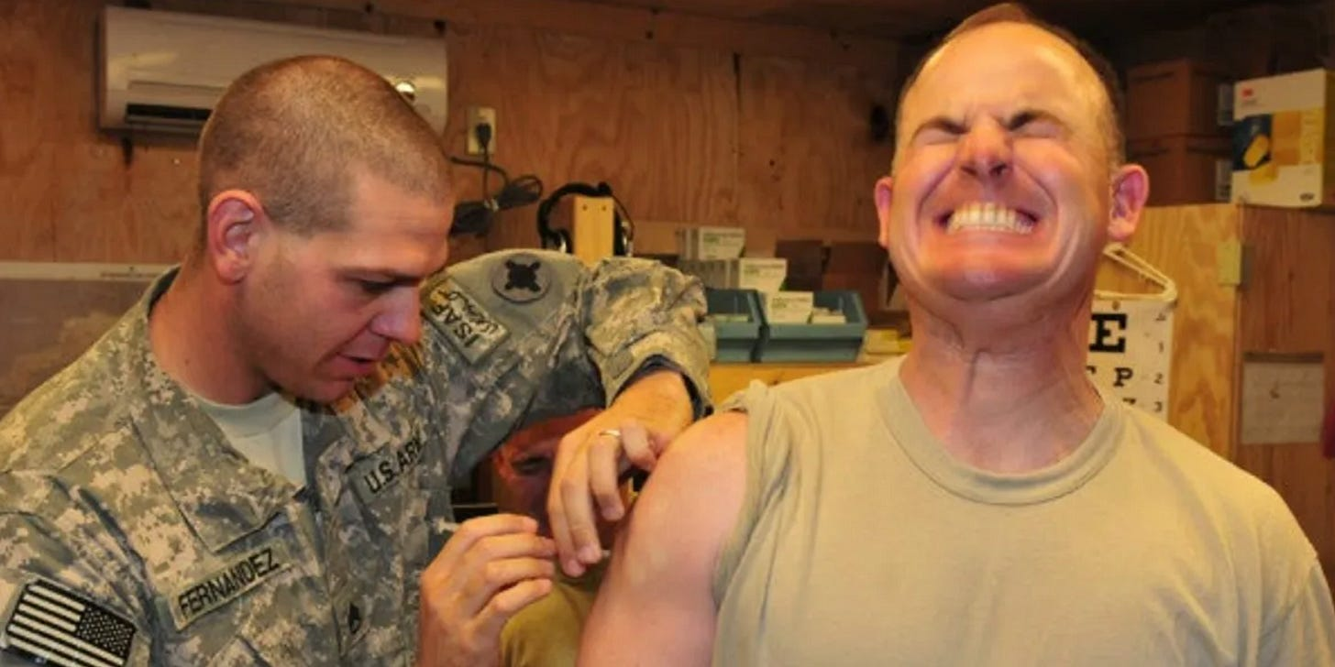](https://substackcdn.com/image/fetch/f_auto,q_auto:good,fl_progressive:steep/https:/substack-post-media.s3.amazonaws.com/public/images/8525eb6e-5b99-4064-99e9-6ebc72007d9f_1804x902.png)](https://substackcdn.com/image/fetch/f_auto,q_auto:good,fl_progressive:steep/https%3A%2F%2Fsubstack-post-media.s3.amazonaws.com%2Fpublic%2Fimages%2F8525eb6e-5b99-4064-99e9-6ebc72007d9f_1804x902.png" \t "_blank)

By A Midwestern Doctor

**Executive Summary:**

* One of the most troubling consequences of the COVID-19 vaccines are **the implications for airline safety**-- there have been numerous harrowing cases recently involving airline pilots having heart attacks or dying, which, almost resulted in  a catastrophe .
* A strong case can be made that much of what we have seen with the COVID-19 vaccine policies and mandates were beta-tested by the Department of Defense (DoD) with the remarkably dangerous anthrax vaccines 20 to 30 years ago.
* Although maintaining the health of pilots is critically important for the military, continuing the anthrax vaccine program took priority over the pilots’ welfare.
* **Observing how the military handled these issues is thus quite instructive for comprehending the gross malfeasance that can be seen in the U.S. government’s current actions.**

**Introduction**

Now that **the narrative** is beginning to shift, those who supported it are grasping for reasons to explain their incorrect decisions to

1. support lockdowns,
2. uphold the denial of early treatment for COVID-19, and
3. advocate for perpetual vaccine mandates.

For example:

* The [first widespread plea for amnesty](https://amidwesterndoctor.substack.com/p/dissecting-the-deceptive-plea-for) for past vaccines misconducts, argued that “we didn’t know”, and cited the lack of data to justify the nonsensical approach that was taken to handling the pandemic.
* The second such plea [from Scott Adams](https://twitter.com/ScottAdamsSays/status/1616904705195794432) essentially said that those who chose to oppose the narrative had won a coin flip and got lucky with the choice they followed.
* The most recent plea was a bit more honest, [but still shared many of the issues seen in the previous ones](https://amidwesterndoctor.substack.com/p/dissecting-the-deceptive-plea-for), and refused to acknowledge the key mistakes that were made.

I, in turn, have identified two characteristics that kept some people from being pulled into the narrative early on, and **in many cases, one without the other was not sufficient to prevent a person from vaccinating** (e.g., I know quite a few people who had serious objections to the childhood vaccine program, but nonetheless chose to receive a COVID vaccine).

**First**, **the majority** of people utilize the “[social proof](https://en.wikipedia.org/wiki/Social_proof)” heuristic, whereby they typically make decisions based on the experiences of their peers. The social proof heuristic (commonly associated [with the Asch experiments](https://igorchudov.substack.com/p/vaccine-skeptics-are-the-true-critical)) helps to explain why a nonsensical message being widely disseminated throughout the media, rapidly results in many members of the public then adopting it, and why the medical profession can often become incapable of seeing evidence that challenges a prevailing orthodoxy.

Conversely, there is always **a minority** of the population who **do not require social proof** to make decisions, and they will typically be the first to adopt a new trend (such as buying a stock before everyone else catches on and its value skyrockets). I have found that virtually every individual I’ve gotten to know who bucked the COVID-19 narrative has shared this personality trait.

**Second**, the same types of crimes tend to be perpetrated repeatedly on the public, so those who become wise to them are less likely to fall for them in the future. In the case of COVID-19, almost every single misdeed that we saw transpire had played out in the past (e.g., RFK has done a remarkable job bringing attention to what Anthony Fauci [did in the early days of HIV](https://www.amazon.com/Real-Anthony-Fauci-Democracy-Childrens-ebook/dp/B08XQYGC68), and **how he used an almost identical script for COVID-19**). Because of this, if you can learn what transpired before, you can prevent it from happening again, and putting a spotlight on these longstanding issues is a key focus of [*The Forgotten Side of Medicine*](https://amidwesterndoctor.substack.com/).

In addition to the early days of AIDS, one of the most important precedents for the COVID-19 response was the largely forgotten anthrax vaccine debacle.

**Gulf War Syndrome (GWS)**

The Gulf War was a rapid and overwhelming victory for the United States that had very few battlefield [casualties for our armed forces](https://pubmed.ncbi.nlm.nih.gov/8071721). However, soon after the war, almost 36% of soldiers ([approximately 250,000 of the 697,000 who served](https://www.va.gov/gulfwaradvisorycommittee/docs/GWIandHealthofGWVeterans_RAC-GWVIReport_2008.pdf)) came down with a debilitating illness that eventually came to be known as “[Gulf War Syndrome](https://amidwesterndoctor.substack.com/p/the-story-behind-sudden-death-syndromes) (GWS).” Initially, the military gaslighted the veterans by insisting that the illness was due to stress (which for many reasons was nonsensical), and then introduced a variety of contradictory studies to explain what else could be causing GWS.

Although a case can be made for many of the potential causes of GWS, by far the strongest case exists for the experimental anthrax vaccination campaign that was conducted during the Gulf War. This is because GWS was almost nonexistent in the other nations who participated in the Gulf War but did not vaccinate their troops, and an illness identical to GWS was observed in troops who were vaccinated but never left the United States (including those who were vaccinated a decade after the Gulf War).

[[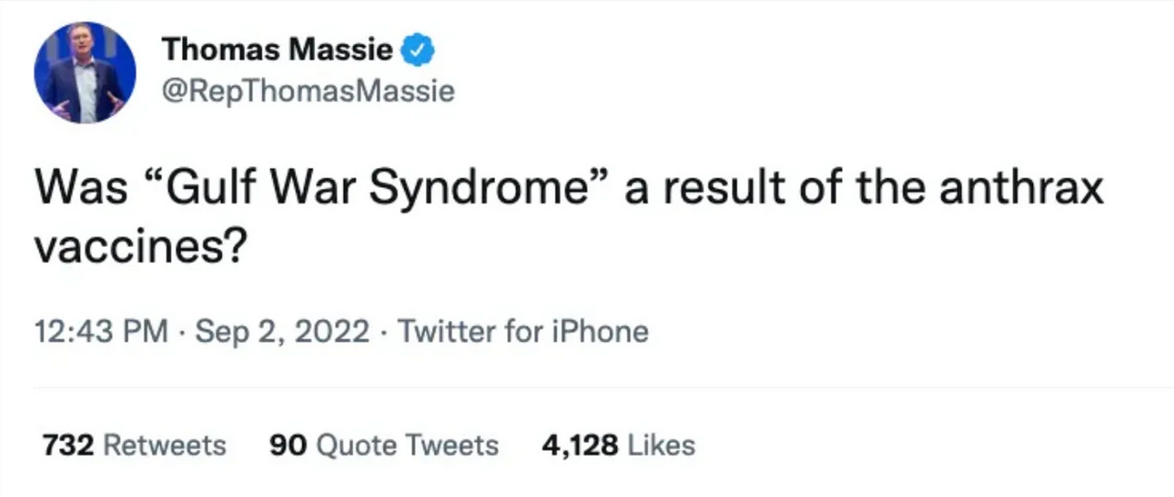](https://substackcdn.com/image/fetch/f_auto,q_auto:good,fl_progressive:steep/https:/substack-post-media.s3.amazonaws.com/public/images/2a3e7179-1acd-4713-b47b-1d4f73bd181a_1806x764.png)](https://substackcdn.com/image/fetch/f_auto,q_auto:good,fl_progressive:steep/https%3A%2F%2Fsubstack-post-media.s3.amazonaws.com%2Fpublic%2Fimages%2F2a3e7179-1acd-4713-b47b-1d4f73bd181a_1806x764.png" \t "_blank)

*As this recent*[*tweet*](https://twitter.com/RepThomasMassie/status/1565787557333549057)*by a member of congress shows, many still consider the anthrax vaccines the causative agent of GWS.*

In addition to the COVID-19 vaccines, a few other vaccines that were administered to the general population were dangerous enough to provoke widespread resistance to their use. The original smallpox vaccine (which frequently failed to work) [had a catastrophic rate of injuries](https://www.who.int/groups/global-advisory-committee-on-vaccine-safety/topics/smallpox-vaccines) and inspired [one of the largest protest movements of the era a century ago](https://amidwesterndoctor.substack.com/p/the-smallpox-pandemic-response-was) to end the vaccine mandates (which ultimately played a critical role in ending smallpox). In recent times, smallpox vaccination has been reserved for the military, [where its use was halted](https://rwmalonemd.substack.com/p/safe-and-effective) due to the significant adverse events it created.

First approved in 2006, the human papillomavirus ([HPV) vaccine](https://rwmalonemd.substack.com/p/what-happens-to-vaccine-clinical) (which, [like the COVID-19 vaccine](https://amidwesterndoctor.substack.com/p/what-happened-to-the-covid-19-vaccine), was approved based on fraudulent clinical trials [that concealed many adverse events by gaslighting the trial participants)](https://rwmalonemd.substack.com/p/what-happens-to-vaccine-clinical) caused a large number of injuries once it entered the market. This, in turn, required the government to utilize a similar playbook with the COVID-19 vaccines so that they could continue being sold.

I believe that a primary mechanism for vaccine injury [is their ability to impair circulation](https://amidwesterndoctor.substack.com/p/why-does-every-vaccine-often-cause) (e.g., by causing blood cells to stick together), something most frequently observed in the most dangerous vaccines (e.g., [the spike protein made by the COVID-19 vaccines causes this to happen](https://www.biorxiv.org/content/10.1101/2022.11.24.517882v1)). Once you know how to identify these injuries, [you can frequently observe](https://amidwesterndoctor.substack.com/p/why-does-every-vaccine-often-cause) subtle neurological deficits arising from microstrokes in vaccinated individuals. One of the most striking effects attributed to the anthrax vaccine (I do not know of any other vaccine where this was observed) [was that children of vaccinated mothers](https://amidwesterndoctor.substack.com/p/why-does-every-vaccine-often-cause) were born without limbs, a birth defect known to arise from significant circulatory impairment to the fetus (and it is [now advised](https://en.wikipedia.org/wiki/Anthrax_vaccine_adsorbed) to avoid the anthrax vaccine in the first trimester of pregnancy).

Despite those strong contenders for the most dangerous vaccine, as this article will show, a good case can be made that the anthrax vaccines were the most dangerous vaccine ever administered to a large number of people. The scheme used by the military to conceal their adverse events and [gaslight](https://amidwesterndoctor.substack.com/p/a-primer-on-medical-gaslighting) the injured is thus quite useful for understanding how the COVID-19 vaccines were orchestrated.

**The Anthrax Vaccines**

A division of the military was heavily invested in developing countermeasures for biological weapons, and since anthrax is one of the most dangerous bioweapons in existence, they had worked for decades to create a vaccine against it. Unfortunately, the best vaccine they had been able to develop for anthrax had a variety of shortcomings, such as it was difficult to produce in large batches (with the manufacturer frequently running into quality control issues for their product), requiring 4-6 doses of the vaccine, it was not as effective towards weaponized strains (which is what you actually want to vaccinate against) and taking months for it to create immunity in the recipients.

At the time of the Gulf War, the military was concerned that Saddam Hussein would deploy anthrax against our soldiers. As a result, a vaccination solution was needed, even though no ideal option existed. Immediately before the war began, a suspicious anthrax vaccination campaign was initiated, which many members of the military firmly believe was a mass experiment on soldiers.

For example, countless servicemen who received the vaccine recall a time when they were suddenly being rounded up and sent to a vaccine site for an unspecified vaccine, being told that the vaccine they were going to receive would not be annotated in their medical record, and then having the only record of it be “Vaccine A” on their service card (a “Vaccine B,” thought to be one for the botulin toxin, was also sometimes given in this manner). Similarly, as resistance to the anthrax vaccine grew (following more and more stories of severe injuries or death from it), the military became more and more aggressive about mandating it on everyone, frequently placing servicemen in a position where they could either vaccinate or be court-marshaled.

This documentary gives an idea of the human cost of this program (as you watch it, you will notice an eerie number of parallels to what we are seeing now):

[[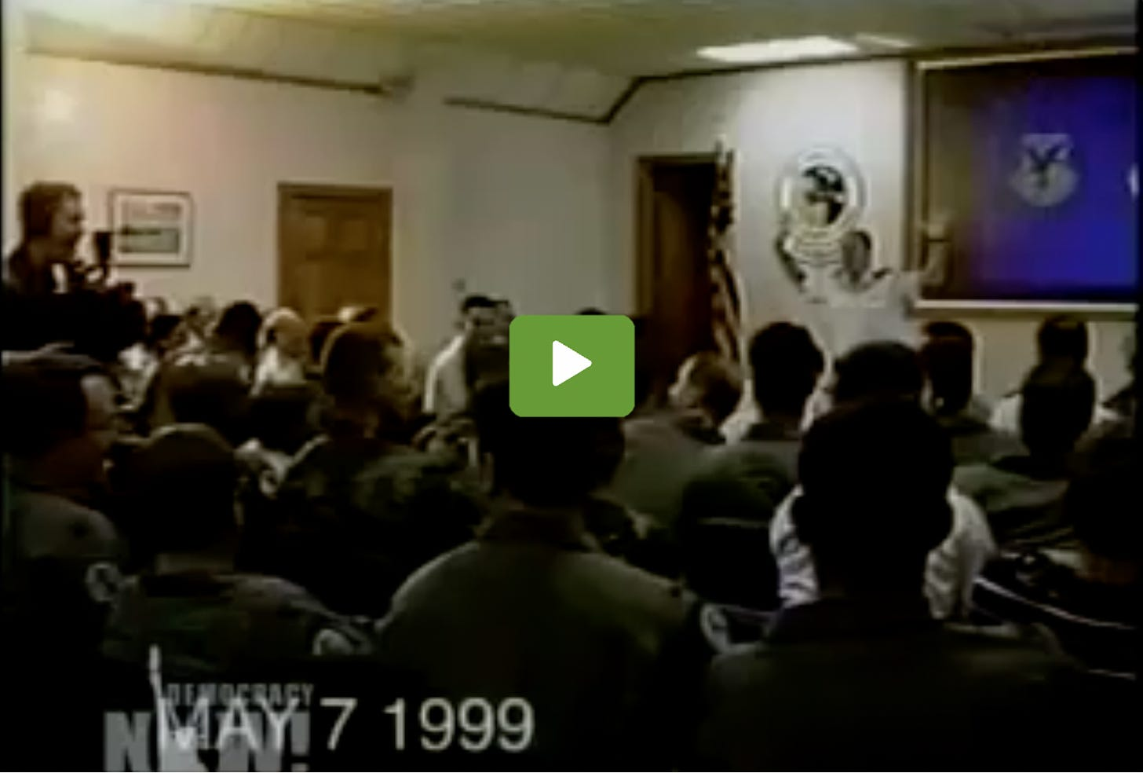](https://rumble.com/v28wj24-direct-order-anthrax-vaccine-doccumentary.html)](https://rumble.com/v28wj24-direct-order-anthrax-vaccine-doccumentary.html" \t "_blank)

The anthrax vaccine campaign continued long after the Gulf War ended, and eventually, the body count from it resulted in [a 1998 law](https://www.rand.org/content/dam/rand/pubs/monograph_reports/2005/RAND_MR1018z9.pdf) being passed that for the most part prohibited members of the military from being forced to take experimental (non-FDA approved) medications. Later [in 2004](https://wwwnc.cdc.gov/eid/article/13/7/06-1188_article), after a court overturned the anthrax mandate, a law was enacted to allow certain emergency-use authorizations. Sadly, as vaccine-injured friends in the military have shared with me (who for months first tried to lawfully avoid the illegal COVID-19 vaccine mandate), the military chose to disregard the legal process they were required to follow this time around.

The anthrax catastrophe also prompted congressional investigations of the DoD that exposed the same system that I believe was implemented to force the COVID-19 vaccines on the American population. During these proceedings in Congress, the DoD was uncharacteristically evasive in reporting their actions.

*Note:*[*Meryl Nass M.D*](https://merylnass.substack.com/)*., has actively advocated for the vaccine-injured servicemen and directly participated in legislative proceedings regarding the vaccines. I have learned a great deal about the vaccines through direct correspondence with her.*

At this point, there are a few hypotheses to explain why the [anthrax vaccine](https://en.wikipedia.org/wiki/Anthrax_vaccine_adsorbed) was so harmful. The most probable one (which Nass believes) is that many shortcuts were taken to be able to vaccinate the military in time for their deployment during the Gulf War. This was particularly problematic because the anthrax vaccine was an inherently dirty vaccine since its manufacturing process (which involved culturing, killing, and then purifying large numbers of anthrax bacteria) produced a substance that was highly likely to produce adverse reactions in the recipients, and was challenging to filter.

Due to the vaccine being produced in a rushed manner for the military, steps that could have made the vaccine cleaner were skipped. For example, when the manufacturer, Bioport, was investigated by the Government Accountability Organization (the GAO serves as Congress’s watchdog), it [was discovered that Bioport](https://archive.is/TGVip#selection-159.263-166.0) exchanged the filters on the final vaccine product to larger ones that did not become clogged (but likewise were no longer as effective for purifying the vaccine), and failed to notify the FDA of this critical change. Similarly, the FDA also had concerns about other aspects of Bioport’s quality control, [repeatedly cited Bioport](https://californiahealthline.org/morning-breakout/anthrax-fda-cites-bioport-for-production-problems/) for their manufacturing processes, and [suspended shipments of the vaccine from their facility](https://www.salon.com/2001/10/15/anthrax_vaccine/).

Bioport ultimately had to change its name (presumably due to the bad press it garnered from the anthrax vaccine), and the defense contractor was renamed Emergent Biosolutions. Recently, it was tasked with manufacturing Johnson & Johnson’s COVID-19 vaccine, and after quality control issues emerged, Emergent Biosolutions was required by the FDA [to dispose](https://www.cbsnews.com/news/quality-control-issues-force-johnson-johnson-to-scrap-doses-of-covid-19-vaccine/) of millions of [improperly produced doses](https://www.cnbc.com/2021/04/21/fda-finds-poor-conditions-at-baltimore-plant-that-ruined-millions-of-doses-of-jj-covid-vaccine.html). It should be noted that FDA inspectors [have come forward](https://www.vanityfair.com/news/2020/12/fda-covid-vaccine-plant-inspectors) and disclosed that there are serious deficiencies in America’s vaccine manufacturing facilities (which the FDA has done very little to address), and that these quality control issues became much worse during Operation Warp Speed (the accelerated process to mass product COVID-19 vaccines).

*Note: There are also two alternative hypotheses to explain the toxicity of the anthrax vaccines which both have compelling but inconclusive evidence supporting them. The* ***first*** *was that the vaccine deployed upon the military contained a (then experimental) squalene adjuvant which caused significant side effects (this hypothesis is discussed within the book*[Vaccine A](https://www.amazon.com/Vaccine-Government-Experiment-Killing-Soldiers/dp/0465021824)*). The* ***second*** *was that many of the symptoms experienced by the vaccine recipients came from a weaponized mycoplasma (this hypothesis has been extensively discussed*[by Garth Nicholson](https://rumble.com/v29598o-garth-nicolson-weaponized-mycoplasma.html)*).*

**Airline Pilots**

Although there are many fears about flying on airlines, in reality, they are [by far the safest mode of transportation](https://injuryfacts.nsc.org/home-and-community/safety-topics/deaths-by-transportation-mode/). This safety record has been a result of the aviation industry and governments around the world assembling a robust system (e.g., a co-pilot for every airplane) to eliminate the risk of any potential accident. Similarly, whenever an accident nonetheless occurs, it is extensively investigated so that the error can be identified and prevented from happening again.

Since the COVID-19 vaccines have come out, numerous **disturbing incidents have been reported of pilots who lost the ability to fly following vaccination**. In my own circle,

* a close friend and physician had a patient whose spouse was a pilot for a major commercial airline. Following vaccination, this pilot developed permanent blurred vision and headaches, and has since been grounded.
* Likewise, on a short flight last year (approximately 90 minutes in duration), once we landed, paramedics had to remove a passenger from the plane for heart issues (whom, based on the conversations I heard, I inferred that the patient had likely been both boosted and vaccinated).

Since the vaccines were rolled out, numerous high-profile events have similarly occurred which have raised suspicions that the vaccine is threatening air safety (e.g., [this one](https://stevekirsch.substack.com/p/us-navy-f-35-crash-was-it-vaccine)). However, in each case where a highly unusual crash occurred, the information necessary for me to determine if vaccination was responsible for their death has not been available.  
  
Conversely, **there have been numerous near-misses** where the vaccine appeared to be the causative agent. These include:  
  
•[Patrick Ford](https://bnonews.com/index.php/2022/11/pilot-dies-after-plane-takes-off-from-chicago/) had a fatal heart attack shortly after lifting off from Chicago O’Hare. His co-pilot managed to take control and land the plane. This is the most dangerous time a pilot can become incapacitated and it is extremely fortunate that the experienced co-pilot was able to save the lives of those on that flight.

•[Bob Snow](https://childrenshealthdefense.org/defender/pilots-injured-covid-vaccines-speak/) suffered a sudden cardiac arrest immediately after landing at the Dallas-Fort Worth airport.  
  
•[Wilburn Wolfe](https://childrenshealthdefense.org/defender/pilots-injured-covid-vaccines-speak/), 11 days after receiving the J&J vaccine, developed a migraine-like headache. Two days later, while not on duty, he had a seizure. After the seizure ended, he was paralyzed on the right side of his body. At the hospital, it was discovered that he had had a hemorrhagic stroke (a brain bleed). He was put in a medically induced coma and ultimately died 17 days after his initial vaccination.  
  
•[Cody Flint](https://childrenshealthdefense.org/defender/pilots-injured-covid-vaccines-speak/), an agricultural pilot, had a reaction immediately following vaccination that progressively worsened, and two days later, while flying , became severely disoriented but miraculously, was able to land safely.

[[](https://twitter.com/MidwesternDoc/status/1624267875010883584)](https://twitter.com/MidwesternDoc/status/1624267875010883584" \t "_blank)

[A Midwestern Doctor @MidwesternDoc](https://twitter.com/MidwesternDoc/status/1624267875010883584" \t "_blank)

[Cody Flint had a nearly catastrophic mid-flight blackout from the Pfizer vaccine he has worked to report to the public. When I reviewed Flint's story, I saw many parallels to the fatal plane crash into a UPS truck at a San Diego suburb. The cause of that crash remains "unknown."](https://twitter.com/MidwesternDoc/status/1624267875010883584" \t "_blank)

[4:43 AM ∙ Feb 11, 2023](https://twitter.com/MidwesternDoc/status/1624267875010883584" \t "_blank)

*Flint’s full interview can be found*[*here*](https://www.youtube.com/watch?v=SJOokonX6KQ)*.*  
  
Given the degree to which the Federal Aviation Administration (FAA) normally prioritizes eliminating any potential risk to airline safety, it is quite strange that they have not investigated any of these cases, and instead have declared that the COVID-19 vaccines are safe and effective. Fortunately, Steve Kirsch was recently able to bring public attention to this issue.  
  
[Kirsch discovered](https://stevekirsch.substack.com/p/the-faa-has-very-quietly-tacitly/comments) that in October 2022, the FAA quietly changed the acceptable electrocardiogram (EKG) threshold to be medically cleared to fly by extending the allowable PR interval past the 200 millisecond threshold ([something known to correlate](https://jamanetwork.com/journals/jama/fullarticle/184145) with an increased risk of heart conditions—discussed further in [this interview](https://rumble.com/v25wb0w-interview-with-cardiologist-thomas-levy.html)). This change implies that the FAA noticed a large number of pilots were developing abnormal EKG findings, and this change was required to maintain our supply of commercial pilots. Although the FAA has denied this theory, they have simultaneously failed to provide an explanation for **why this change was made**.  
  
Many pilots in the airline industry have **also** directly reached out to Kirsch to share

1. how they have observed debilitating COVID vaccination side effects take away pilots’ ability to fly.
2. Additionally, they have also noted that there has been [a dramatic increase in the death rate of commercial pilots](https://stevekirsch.substack.com/p/pilots-are-dying-at-southwest-airlines) since vaccines were mandated throughout the industry.

**Anthrax-Vaccinated Pilots**

The military places a high value on its pilots (they cost a lot to train, and the aircrafts they fly are even more expensive). Unfortunately, both previously with the anthrax vaccines, and presently with the COVID-19 vaccines, their value does not seem to outweigh the forces within the DoD that are committed to continuing their biological countermeasures programs.  
  
Following the Gulf War, one of the primary sites where the dangerous anthrax vaccines were deployed was Dover Air Force Base (located in Biden’s home state of Delaware, with the disaster there unfolding at the time he was their senator). Because many injuries occurred, not surprisingly, many military pilots were also injured and permanently lost their ability to fly. This is a brief compilation of some of them:

[[](https://twitter.com/MidwesternDoc/status/1623784040024395776)](https://twitter.com/MidwesternDoc/status/1623784040024395776" \t "_blank)

[A Midwestern Doctor @MidwesternDoc](https://twitter.com/MidwesternDoc/status/1623784040024395776" \t "_blank)

[The atrocity the military did to our soldiers with the forced & experimental Anthrax vaccines was a beta test for COVID-19. This clip shows how many pilots lost their ability to fly (and so much more) and just how far the military went to gaslighted them.](https://twitter.com/MidwesternDoc/status/1623784040024395776" \t "_blank)

[8:40 PM ∙ Feb 9, 2023](https://twitter.com/MidwesternDoc/status/1623784040024395776" \t "_blank)

[57Likes27Retweets](https://twitter.com/MidwesternDoc/status/1623784040024395776" \t "_blank)

When I wrote this article, I also reached out to a rheumatologist colleague who had previously worked with many at the Veteran’s Administration who had been injured by the anthrax vaccine and asked him if he had ever seen any military pilots who lost the ability to fly. He told me:

Forget flying. These guys were in really bad shape. Many of them couldn’t even drive.

Because of the injuries that the pilots experienced, the GAO launched an investigation into the effects of the anthrax vaccine on our aircrew and pilots. Their [report](https://www.gao.gov/products/gao-02-445) found that:  
  
•Between September 1998 and September 2000, 16% of the pilots and aircrew chose to transfer to a non-flying position or they retired to avoid the vaccine, while 20% of those who remained indicated their intention to leave in the near future.  
  
•Two-thirds of those in the Reserves or National Guard did not support the vaccination program for anthrax or any future biological weapons.  
  
•Most of the reactions experienced from the vaccines were not reported due to fear of retaliation for doing so.  
  
•It was estimated that 37% of those surveyed had received at least one anthrax vaccine, and **85%**of this group experienced an adverse reaction (this was more than double the rate claimed by the manufacturer).  
  
•**0.6% of anthrax vaccine recipients**[**experienced blackouts**](https://www.gao.gov/assets/gao-02-445.pdf)**(**Cody Flint—mentioned above—experienced a harrowing blackout while flying)**.**

**Anthrax Vaccine Injured Pilots**

Both [Vaccine A](https://www.amazon.com/Vaccine-Government-Experiment-Killing-Soldiers/dp/0465021824) and [The Vaccine Epidemic](https://www.amazon.com/Vaccine-Epidemic-Corporate-Coercive-Government/dp/1620872129) contain many heart-wrenching, tragic stories of what happened to pilots who were injured by the anthrax vaccine. In this section, I will quote some of them. When you consider the critical importance of pilots to the military, it is astounding that the issue was ignored and the injured were instead severely [gaslighted](https://amidwesterndoctor.substack.com/p/a-primer-on-medical-gaslighting) by the military.

In 1997 I was stationed at Dover AFB, Delaware. In the course my tenure at Dover I helped follow-up on ill Gulf War era veterans for the Comprehensive Clinical Evaluation Program (CCEP) in the Tri-State region. **Most** reported autoimmune illnesses such as: severe arthritic pain, rashes, nervous system damage, numbness and tingling in extremities, excessive fatigue, Multiple Sclerosis, vertigo and “gray-outs,” cardiac and gastrointestinal problems. They also complained of problems receiving care, often citing active duty medical providers who told them that their illnesses ***were all in their head***. Unfortunately this message is still being propagated in military medicine and being reportedly conveyed to new medical providers who enter active service.

**In the fall of 1998** I began noticing similar clusters of unexplained illnesses within our healthy and young aircrew population. I had witnessed first hand bizarre symptomatology and illnesses atypical for the population and age group. **Strikingly** the illness reported were many of the same as were previously reported by Gulf War era veterans seven years earlier. Unfortunately the common denominator was the anthrax vaccine. Equally unfortunate, the patients were treated the same as veterans who had served seven years earlier.

For instance,

* Patient TSGT D.B. (active duty aircrew member) became ill following anthrax vaccination. He developed myocarditis, (possible autoimmune etiology) cardiac arrhythmia and inflammation around the heart sac. A short time later, patient D.B. had to have his heart shocked out of an arrhythmia. Several days later a clot dislodged from his heart and he suffered a mini stroke. To the best of my knowledge this vital aircrew member was medically boarded [sic] never to fly again. This was not an isolated incident.
* In fact Dover’s Chief of Safety, Colonel J, a C-5 Galaxy pilot, became so ill following vaccination that he reportedly had to turn the flight controls over to the co-pilot and slept on the aircraft’s bunk during a flight over the Atlantic.
* Another pilot who also was in transient flight over the Atlantic reported a similar problem. His name was Captain He [sic] developed unexplained vertigo (GRAY-OUTS), severe joint aches and pain and rare lesions throughout his internal organs.
* Captain J.R. a versatile and combat tested pilot found it difficult to get out of bed due to arthritic bone and joint pain. His experience with the anthrax vaccine is well documented in congressional record. His post vaccination blood work showed seroconversion to the autoimmune marker, ANA.”
* Lieutenant Colonel Jay Lacklen [featured in the previous video clip] is a decorated combat pilot who had no pre-existing arthritic symptoms. Post vaccination he developed an autoimmune arthritic condition and displayed a positive blood marker for autoimmunity.”
* Captain Cheryl Angerer [also featured previously], another highly skilled pilot developed numbness and tingling (paresthesias) on one side of her body following anthrax vaccination from the same lot number as others who had fallen ill. Captain Angerer was so incensed at her medical treatment and anthrax vaccine induced illness that she resigned publicly after developing an autoimmune condition. Her post vaccination blood work showed the blood marker for autoimmunity, ANA.
* TSGT J.M. is a former enlisted aircrew “member who is permanently grounded due to a severe autoimmune condition involving severe bone and joint pain, memory loss and unexplained “gray-outs.” His pre-vaccination blood work showed no evidence of autoimmunity while his post vaccination blood work showed positive evidence of autoimmunity.
* Lieutenant Jamie Martin [also featured previously] developed severe bone and joint pain following vaccination. This highly trained pilot refused his third vaccination due to previously encountered illness associated with the anthrax vaccine and was discharged from the service.
* Another highly qualified pilot from the USAFR at Dover also testified that day (under oath), Captain Jon Richter. He developed autoimmune arthritis following vaccination.
* Finally, two Air Force Reserve pilots from Dover Air Force Base **suffered strokes** following anthrax immunization. One of them was landing a Fokker- 100 passenger plane in January 2002 with around eighty passengers and crew at Chicago’s O’Hare International Airport when he suffered an “embolic stroke”—a stroke from a blood clot in his brain. Descending to 13,000 feet and coming up fast on the runway, this pilot felt the fingers on one of his hands go numb. As copilot, he was talking to the O’Hare tower when he started to slur his words like he had just come out of a dentist’s office with a mouth full of novocaine. The plane landed safely, but upon examination by doctors in Chicago, this pilot tested positive for antinuclear antibodies, which are antibodies that attack the nuclei of cells; these antibodies occur with a number of different autoimmune diseases. Military doctors, however, attributed this pilot’s clot formation and subsequent stroke to a congenital heart defect [this is also what was pronounced for other public figures with unexpected strokes in the COVID-19 vaccine era [such as Justin Bieber’s wife](https://stevekirsch.substack.com/p/the-cause-of-justin-biebers-facial)].

*Note: I recently learned of a case where a friend discovered an unconscious woman had crashed into his property after having a sudden “unexplained” stroke while driving. He was fortunately able to get to her to the hospital in time to save her life.*

There were more individuals within the Reserve Airlift Wing at Dover AFB who received the same lot number of vaccines that also reported severe and sub-clinical unexplained illness and autoimmunity “unexplained illness and autoimmunity ["]. There were also many more individuals with sub-clinical ailments who were afraid to come forward for fear of reprisal.

* Lt. Gen. Roadman assured everyone the vaccine was completely safe and that only a minute percentage of those military personnel inoculated had had a negative reaction [whereas the GAO found 85% did]. Meanwhile, I was encountering more of my squadron mates who were vaccinated that said they too had experienced various reactions including
* tinnitus,
* dizziness,
* muscle and
* joint pain and
* in one case black-outs.

However, most were attempting to keep a low profile and did not readily discuss these matters for fear of reprisal.

In the end the problems at Dover were ascribed to:

* whining pilots,
* malingerers,
* children,
* troublemakers,
* liars,
* rumormongers,
* group-think,
* stress,
* psychosomatic maladies and
* artifact in reporting.

Unfortunately this view is the accepted assessment of the anthrax vaccine problems at Dover by our military and civilian leadership as well as a corporate media that has abandoned its obligation to roll up its sleeves and ferret out the truth. In the end something very wrong occurred at Dover.

At Dover Airforce Base, [a survey completed](https://journalofethics.ama-assn.org/article/informed-consent-military-anthrax-vaccination-case/2007-10) by members of one unit found that **32%** experienced serious side effects such as severe joint pain, memory loss, and arthritis following anthrax vaccination. The wave of injuries following anthrax vaccination caused the commander of Dover Air Force Base, Colonel Felix Grieder, to become concerned enough to contact the Pentagon about them.  
  
After the Pentagon stonewalled him and refused to address any of his concerns, Grieder suspended the program (a move that cost him his career). Six days later, numerous high-ranking officers from the Pentagon showed up to host a town hall on the vaccines (which shocked many at the base as it is exceedingly rare for a response like this by the military’s chain of command). They repeatedly assured the servicemen that the vaccines were safe, and trusting his superiors, Grieder reinstated the mandate.  
  
Although **so much more could be written on this debacle**, one thing particularly stood out to me when I reviewed testimonies of servicemen from Dover Airforce Base: if the issues with the anthrax vaccine on soldiers were not addressed, the civilian population would be next.

**Conclusion**

I have repeatedly observed cases where smaller demographics of people are severely injured by an unsafe pharmaceutical, and in each case, because it does not affect enough of the general population, it is possible for the injustice to be swept under the rug.  
  
One of the most iconic poems from the Holocaust (that in many ways I live my life by) goes as follows:

*First they came for the socialists, and I did not speak out—  
     Because I was not a socialist.*

*Then they came for the trade unionists, and I did not speak out—  
     Because I was not a trade unionist.*

*Then they came for the Jews, and I did not speak out—  
     Because I was not a Jew.*

*Then they came for me—and there was no one left to speak for me.*

I would argue that

1. had we spoken out for the gay community when Fauci exploited them for his (and his sponsor’s) benefit during the early days of HIV, the disastrous COVID-19 playbook could not have been implemented. Similarly,
2. had we spoken out more for the veterans injured by the anthrax vaccines, I do not believe that the COVID-19 response could have happened.

Given the extent to which the government and airlines typically go to ensure airline safety, it is astonishing that nothing has been done to protect the fitness of our pilots. However, if we take a step back to observe what happened throughout the military with the anthrax vaccines (which I would argue were a beta test by the Department of Defense for the COVID-19 response), this unwillingness to acknowledge the elephant in the room makes much more sense. I thank you for your time in reading this and helping to bring attention to this **forgotten medical tragedy**.

***The Forgotten Side of Medicine Substack is written* by A Midwestern Doctor (who wrote the above essay)**

Here I do my best to expose both the light and dark within medicine that has remained hidden. My hope is that knowledge can improve your health and the health of those around us.

[The Forgotten Side of Medicine](https://amidwesterndoctor.substack.com/)

Who is Robert Malone is a reader-supported publication. To receive new posts and support my work, consider becoming a free or paid subscriber.

Subscribed

Thank you for reading Who is Robert Malone. This post is public so feel free to share it.